**Manuals for ‘View Career Application’**

**Brief of the ‘View career application’ –** This is the page where we can see the applicant details

**1. How to see the applicant details-.**

Steps:

1. Login to the site and go to ‘Career’ tab and click on ‘View career application ’.
2. On ‘View career application’ page the listing of applicant details will display.
3. On career page if applicant apply for any position and submit his details. On ‘View career application’ page we can see the Qualification, work experience, resume of the applicant.

1.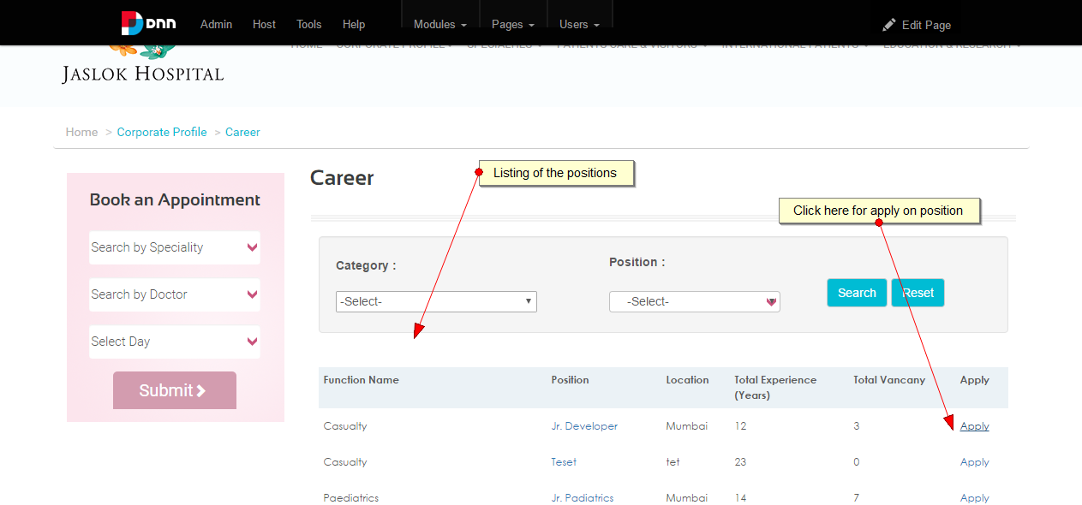

2.

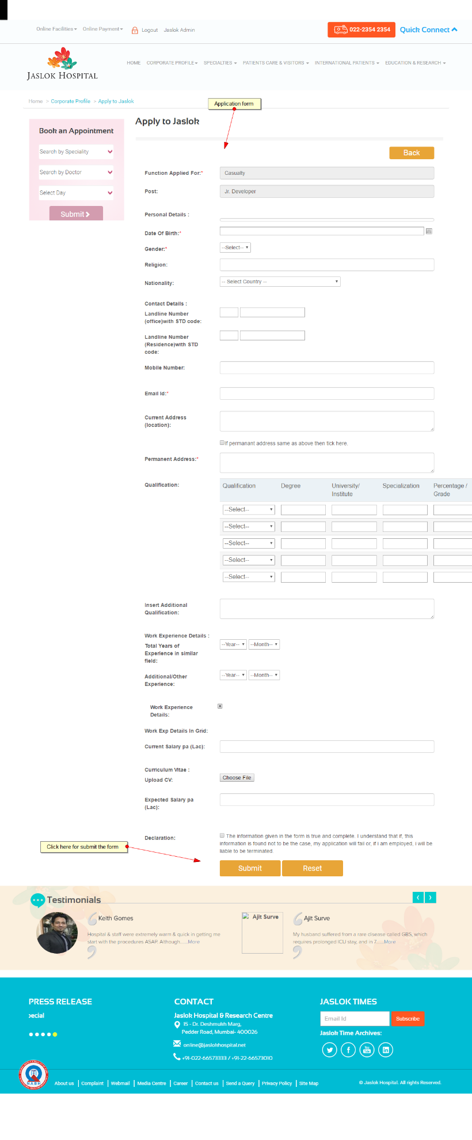

3.

